Architecture Document
Evaluating a Multi-Agent Intelligent Compliance Auditor (MAICA) for Automating AI Regulation Adherence Compared to Traditional Manual Compliance Methods in Ensuring Ethical and Secure AI Deployments

1. Application Architecture
Selected Architecture: Microservices Architecture
The MAICA system is designed using a microservices-based architecture where each auditing component operates as an independent service. This architecture is suitable because the system contains multiple independent agents such as security auditing, model inspection, runtime monitoring, and explainability modules.
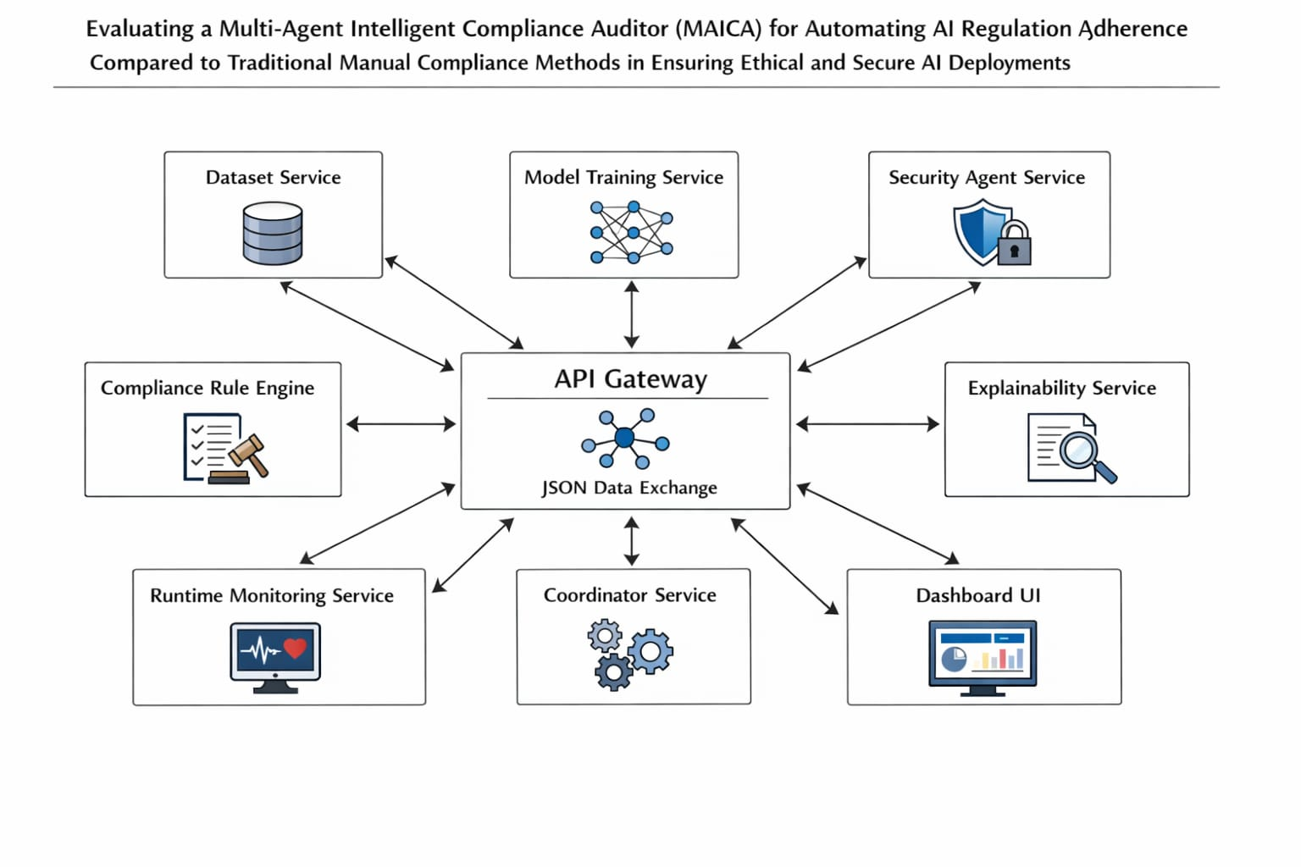

2. Database
1. ER Diagram :
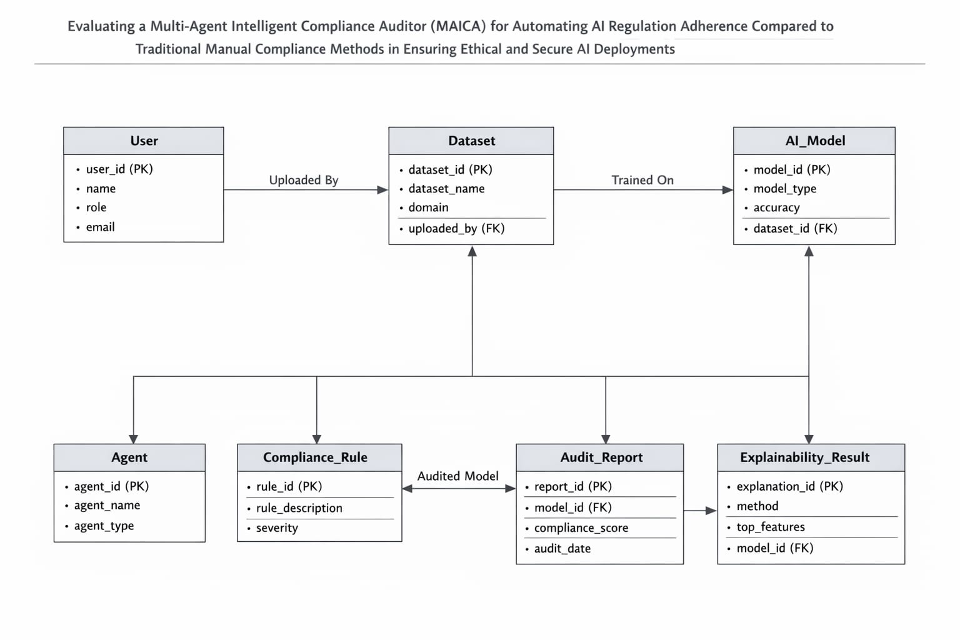
2. Schema Diagram :
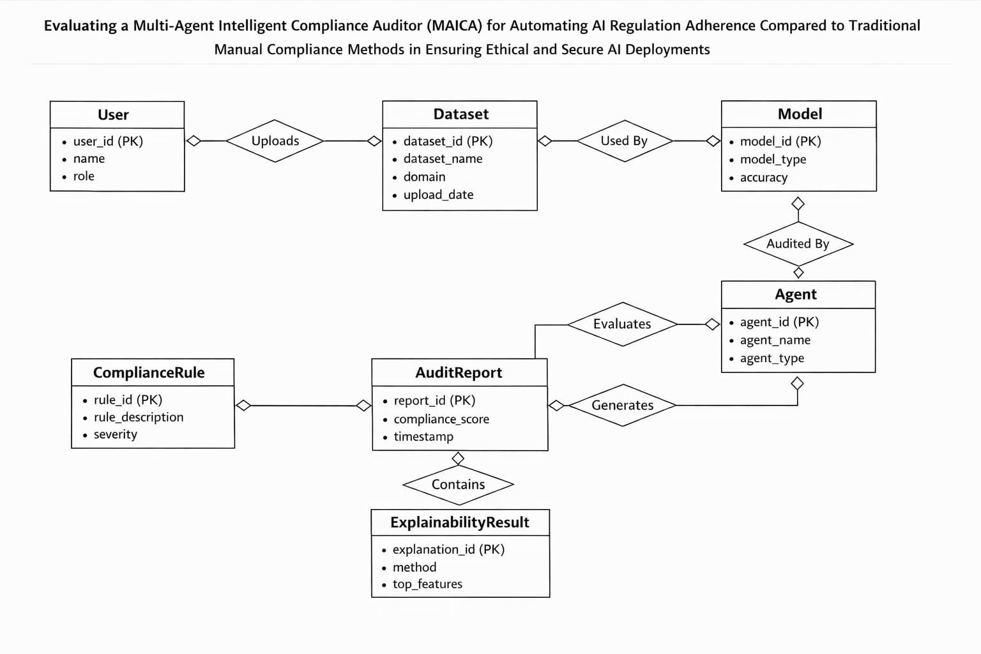
3. Data Exchange Contract
1. Frequency of Data Exchanges
Data exchange in the MAICA system occurs during key stages of the auditing workflow. When a dataset is uploaded, it is shared with the preprocessing and model training modules. After the model is trained, the auditing agents such as the Security Agent, Model Inspection Agent, and Explainability Agent exchange data to evaluate compliance and generate analysis results. These exchanges occur whenever a new model is evaluated or when a compliance audit is triggered by the system.

2. Data Sets
The MAICA system processes datasets from regulated domains to evaluate AI compliance. In this project, two primary datasets are used:
- Healthcare Dataset: Heart Disease dataset used for medical prediction analysis.
- Finance Dataset: Adult Income dataset used for income prediction evaluation.
These datasets are used to simulate real-world AI systems in sensitive domains where fairness, transparency, and regulatory compliance are critical.

3. Mode of Exchanges
Data is exchanged between the modules of the MAICA system using structured communication methods. The primary modes of exchange include:
- API Communication: Used for interaction between system modules and services.
- File-Based Exchange: CSV and JSON files are used for datasets, model outputs, and compliance reports.
- Structured Data Formats: JSON format is used for exchanging audit results and agent outputs between modules.
These communication methods ensure efficient and consistent data flow between the different components of the system.

